Handbook EL-312 Employment and Placement, July 2015, 58 Post Hire Suitability

581.2 Administering the Oath of Office
“The oath of office should be administered as part of new–employee orientation or on the employee’s first workday, by a person specified in 39 CFR 222, which includes personnel professionals, level EAS–15 and above, and postmasters. The form should be reviewed for completeness and follow–up action taken, as appropriate, based on any revised answers to questions 1 through 13. The Interview Checklist should also be initialed based on the information provided on Form 61. The word swear should be struck when the appointee elects to affirm rather than swear to the affidavit. Only that word may be struck and only when the appointee elects to affirm the affidavits. If appointees have objections to taking the oath, or wish clarification regarding administration of the oath that cannot be handled locally, assistance should be obtained from the appropriate field legal services center.”

“Webster's 1828 edition of the American Dictionary of the English Language defines "oath" as follows:
A solemn affirmation or declaration, made with an appeal to God for the truth of what is affirmed. The appeal to God in an oath, implies that the person imprecates His vengeance and renounces His favor if the declaration is false, or if the declaration is a promise, the person invokes the vengeance of God if he should fail to fulfill it. A false oath is called perjury.

As James Madison famously put it in his Memorial and Remonstrance, written on the eve of the
Framing:
“Before any man can be considered as a member of Civil Society, he must be considered as a subject of the Governor of the Universe: And if a member of Civil Society, who enters into any subordinate Association, must always do it with a reservation of his duty to the General Authority; much more must every man who becomes a member of any particular Civil Society, do it with a saving of his allegiance to the Universal Sovereign.”

[Point of the oath:]
“Should the Postal Service conclude that a substantial burden exists in a particular case, there would nevertheless be a compelling interest in ensuring, including through an oath, that prospective employees both supported the Constitution and were committed to faithfully performing their jobs? The clear evidence of the compelling interest in ensuring support for the Constitution through an oath is the inclusion of such a requirement in the Constitution, not only for members of Congress and principal officers but also for “all judicial and executive officers,” both federal and state, and all state legislators. Such persons “shall be bound by Oath or Affirmation, to support this Constitution.” U.S. Const. art. VI, cl. 3.The Constitution itself, in the Fourteenth Amendment, emphasizes the importance of this requirement by making certain actions that are inconsistent with the oath—“engag[ing] in insurrection or rebellion against” the Constitution, or giving “aid or comfort to the enemies thereof”—and done by one who had “previously taken” it the basis for barring him from holding any state or federal office. Id. amend. XIV, § 3. And the First Congress demonstrated the requirement’s importance by implementing it through its very first enactment. See An Act to regulate the Time and Manner of administering certain Oaths, ch. 1, § 1, 1 Stat. 23, 23 (1789).The courts have similarly recognized that the Founders’ inclusion of the requirement of a “support” oath in the Constitution (and of a slightly different oath for the President) reflects a governmental interest of the highest order. As the Supreme Court explained in American Communications Association v. Douds: Clearly the Constitution permits the requirement of oaths by office-holders to uphold the Constitution itself. The obvious implication is that those unwilling to take such an oath are to be barred from public office. For the President, a specific oath was set forth in the Constitution itself. Art. II, § 1. And Congress has detailed an oath for other federal officers. Obviously the Framers of the Constitution thought that the exaction of an affirmation of minimal loyalty to the Government was worth the price of whatever deprivation of individual freedom of conscience was involved.”
[Faithfully Discharge of duties:]
“This dual compelling interest in ensuring minimal loyalty and conscientious conduct plainly includes the Postal Service, many of whose employees have unique access both to the mail—which contains valuable items such as social security checks, tax returns, and correspondence—and to public and private buildings. See United States v. Lamb; , 6 F.3d 415, 421 (7th Cir. 1993) (“a government employee who takes an oath to uphold the law (as does a mail carrier) and who performs a government function for a public purpose such as delivery of the U.S. mail, is in a position of trust”);USPS v. Am. Postal Workers Union,736 F.2d 822, 825 (1st Cir. 1984) (“Any postal position which handles mail is one entrusted with items of importance and value by the public. Envelopes containing government checks or items which are insured disclose to all who see them the valuable items inside.”); USPS v. Nat’l Ass’n of Letter Carriers, 631 F. Supp. 599, 601 (D.D.C. 1986) (“The inexorability of the mails, upon which literally millions depend daily, is equally compromised whether postal workers are derelict in their duties for reasons of avarice, indolence, or distractive vices . . . ; the mails are
simply too important.”).Third, both Biklen and the early statutes, discussed above, suggest that the Postal Service oath’s “faithfully discharge” clause is as essential as the “support” language to furthering the compelling interest. The consistent practice of Congress—since the 1790s—in requiring at least a pledge of faithful performance from prospective Post Office officers and employees (in addition to the support oath) reinforces this understanding. See An Act to establish the Post Office and Post Roads within the United States, 1 Stat. at 234(1792); An Act to establish the Post-office and Post-roads within the United States, ch. 23, § 4, 1 Stat. 354, 358 (1794); An Act to establish the Post-Office of the United States, ch. 43, § 2, 1 Stat. 733, 733 (1799); An Act regulating the Post-office Establishment, ch. 37, § 2, 2 Stat. 592, 593–94 (1810); An Act to reduce into one the several acts establishing and regulating the Post-office Department, ch. 64, § 2, 4 Stat. 102, 103 (1825).”
C. KEVIN MARSHALL
Acting Deputy Assistant Attorney General
Office of Legal Counsel
(http://www.justice.gov/sites/default/files/olc/opinions/attachments/2015/05/08/op-olc-v029-p0037.pdf )

- 39 U.S. Code § 1011 - Oath of office

Before entering upon their duties and before receiving any salary, all officers and employees of the Postal Service shall take and subscribe the following oath or affirmation:

“I, XXXXXXXX , do solemnly swear (or affirm) that I will support and defend the Constitution of the United States against all enemies, foreign and domestic; that I will bear true faith and allegiance to the same; that I take this obligation freely, without any mental reservation or purpose of evasion; and that I will well and faithfully discharge the duties of the office on which I am about to enter.”
A person authorized to administer oaths by the laws of the United States, including section 2903 of title 5, or of a State or territory, or an officer, civil or military, holding a commission under the United States, or any officer or employee of the Postal Service designated by the Board may administer and certify the oath or affirmation.

- “P.S. Docket Nos. POB 00-209, 271, and 272, December 29, 2000

In the Matter of the Petitions by

CARL A. CURRIER
Refusal to Provide Post Office
Box or General Delivery Service
P.S. Docket No. POB 00-209

JAMES KERNS
Refusal to Provide Post Office
Box or General Delivery Service
P.S. Docket No. POB 00-271

DAVID BAR
Refusal to Provide Post Office
Box or General Delivery Service
P.S. Docket No. POB 00-272

APPEARANCE FOR PETITIONERS:
David Girard, Esq.
Casey Trupin, Esq.
Andrew Ko, Esq.
Columbia Legal Services
101 Yesler Way, Suite 300
Seattle, WA 98104-2528

APPEARANCE FOR RESPONDENT:
Catherine A. Green, Esq.
Civil Practice Section
United States Postal Service
475 L'Enfant Plaza, SW, Room 6403
Washington, DC 20260-1127”

“INITIAL DECISION
This proceeding arises from Petitions filed by Mr. Currier, Mr. Kerns, and Mr. Bar, after they were orally denied post office box service.

In each case, Respondent, the United States Postal Service, filed a Motion for Summary Judgment, arguing that there were no material facts in dispute and that Respondent was entitled to judgment as a matter of law. Petitioners replied with cross-motions for summary judgment. As they are based on similar facts, and raise the same issues, the cases have been consolidated for decision. The following findings of fact are based on all the material submitted by the parties.

FINDINGS OF FACT
1. All three Petitioners are homeless men living in Seattle, WA. In May and June 2000, each of them separately approached postal employees at various Seattle post offices to inquire about post office box service. They each asked about regular post office boxes, "no-fee" post office boxes, and general delivery service. Each made it clear to the postal employees they talked with that they were homeless. (Petitions; Currier Declaration; Bar Declaration; Kerns Declaration (all attached to Petitioners' M/SJ); Merkel Declaration (attached to Respondent's M/SJ)).

2. Each Petitioner was orally denied post office box service. None actually filled out a written application for a post office box (PS Form 1093, see Petitioners' M/SJ, Tab L).1 Each also was given information about the availability of general delivery service at the Seattle Main Post Office. One or more may have been given incorrect information, i.e., that there was a 30-day limit on that service, but this matter is now moot. All Petitioners were informed early on in this litigation that general delivery service was available to them indefinitely. (Petitions; Answers; Zinser Declaration; Green Declaration).

3. Mr. Currier showed one of the postal employees with whom he spoke a photo identification card from the Downtown Emergency Services Center (DESC) but told her he did not wish to use the DESC address as his address in applying for a box (Currier Declaration; Merkel Declaration). Mr. Bar and Mr. Kerns also possess certain identification cards but, as no postal employee who remembers talking to them has been located, it is unclear whether they actually presented these identification cards. The identification cards possessed by all three Petitioners are attached to Petitioners' Motion for Summary Judgment (Bar Declaration; Kerns Declaration; M/SJ, Tabs G, H, I).

4. All three Petitioners were told that they could not obtain a post office box without providing a physical address on their application, or words to that effect. It is not necessary to determine precisely what they were told, or whether the postal employees with whom they spoke correctly stated the rules on eligibility for post office box service. There is no doubt that the three Petitioners were denied box service, and the Postal Service position on their lack of entitlement has been made clear in this litigation.

5. The following provisions of the Domestic Mail Manual (DMM, Issue 55) are pertinent:

D910 Post Office Box Service
Purpose Post office box service is a premium service offered for a

1.1 fee to any customer requiring more than free carrier delivery or
general delivery and for no fee to customers who are not eligible for
carrier delivery . . . .

Proof of An applicant for post office box service, . . ., or a
Physical current box customer seeking renewal must identify his
Address or her physical address (i.e., an individual's
2.3 residence or a business's location) to the postmaster
of the office where service is sought or provided. . . ..

5.0 FEE GROUP ASSIGNMENTS
5.1 a. Post Office With City Delivery. . . . A customer whose physical residence or business location is within the geographic delivery ZIP Code boundaries administered by that city delivery office, who is ineligible for any form of carrier delivery service from that post office, and who does not receive carrier delivery via an out-of-bounds delivery receptacle may obtain post office box service through one box of the smallest available size that accommodates the customer's mail volume at the Group E fee.2 ..

D930 General Delivery and Firm Holdout
1.0 General Delivery

Purpose General delivery is intended [not required] primarily as a temporary
1.1 means of delivery:
a. For transients and customers not permanently located.
b. For customers who want post office box service when boxes are unavailable.

6. The following Postal Bulletin provision is pertinent (PB 21877, 9-29-94):3

Post Office Box and General Delivery
Service for Persons with No Fixed Address

In an effort to assist persons with no fixed address, a homeless person's application for post office box service (Form 1093) may be approved under any one of the following conditions:
1. The applicant is personally known to the post-master or clerk.
2. An unknown applicant submits proper identification such as a valid driver's license or other credential showing the applicant's signature and a serial number, or other indicia that can be traced to the bearer.
3. The applicant provides a verifiable point of contact, e.g., place of employment, shelter, charitable institution, or social service office.

Applicants who cannot meet these conditions may receive indefinite general delivery service as provided in Domestic Mail Manual (DMM) D930. . . ..

7. General delivery mail service in Seattle is provided only at the Seattle Main Post Office, Third and Union Streets. (Zinser Declaration; Nelson Declaration) Group E (no-fee) post office box service is not offered at all in Seattle, and no customers, homeless or otherwise, receive no-fee box service. (Zinser Declaration filed in Bar and Kerns cases)

8. The following excerpts from statues governing the Postal Service are pertinent:
39 U.S.C. §101. Postal Policy

(a) . . . The Postal Service shall have as its basic function the obligation to provide postal services to bind the Nation together through the personal, educational, literary, and business correspondence of the people. It shall provide prompt, reliable, and efficient services to patrons in all areas and shall render postal services to all communities. . . ..

39 U.S.C. §401. General powers of the Postal Service
* * *
(2) to adopt, amend, and repeal such rules and regulations as it deems necessary to accomplish the objectives of this title;
* * *
(10) to have all other powers incidental, necessary, or appropriate to the carrying on of its functions or the exercise of its specific powers.

39 U.S.C. §403. General duties

(b) It shall be the responsibility of the Postal Service--
(1) to maintain an efficient system of collection, sorting, and delivery of the mail nationwide;
(2) to provide types of mail service to meet the needs of different categories of mail and mail users;
* * *
(c) In providing services and in establishing classifications, rates, and fees under this title, the Postal Service shall not, except as specifically authorized in this title, make any undue or unreasonable discrimination among the users of the mails, nor shall it grant any undue or unreasonable preferences to any such user.

39 U.S.C. §404. Specific powers
(a) Without limitation of the generality of its powers, the Postal Service shall have the following specific powers, among others:
(1) to provide for the collection, handling, transportation, delivery, forwarding, returning, and holding of the mail, and for the disposition of undeliverable mail:
* * *
39 U.S.C. §3621. Authority to fix rates and classes
. . . Postal rates and fees shall be reasonable and equitable and sufficient to enable the Postal Service under honest, efficient, and economical management to maintain and continue the development of postal services of the kind and quality adapted to the needs of the United States. . . ..

DECISION
A grant of summary judgment is proper when there are no issues of material fact in dispute and when, as a matter of law, the moving party is entitled to judgment. Celotex Corp. v. Catrett, 477 U.S. 317, 322-24 (1986); Anderson v. Liberty Lobby, Inc., 477 U.S. 242, 247-48 (1986). In this case, both parties have moved for summary judgment. There are no material facts in dispute and summary judgment is appropriate.

Petitioners argue that Respondent has not followed its own regulations in denying post office box service to Petitioners. Specifically, Petitioners argue that DMM §D910.5.1(a) (see Finding of Fact #5) creates an entitlement to no-fee boxes for homeless persons, and that Respondent has failed to follow this regulation.4 Petitioners also argue that they qualify for post office box service under the Postal Bulletin 21877 provision for homeless persons, but that Respondent continues to insist that every applicant must provide a physical address.

Petitioners also make two Constitutional arguments. First, they argue that Respondent's application of its rules on no-fee post office boxes unreasonably discriminates against homeless persons in violation of the Equal Protection clause of the Fifth Amendment. Second, they argue that providing general delivery service at only one location in the city of Seattle unlawfully infringes upon the First Amendment rights of homeless persons.

Most of Respondent's arguments in the motions for summary judgment are directed toward the general delivery rules and the rules governing no-fee post office boxes. As noted earlier (see Finding of Fact #2), part of the first issue is now moot because the Postal Service acknowledges that there is no time limit on Petitioners' entitlement to general delivery service. As to the fact that general delivery is available only at the Seattle Main Post Office, Respondent argues that this is in accordance with the governing regulation, DMM §D930.1.2 (see Finding of Fact #5). Further, Respondent argues that this regulation is a reasonable exercise of the Postal Service's authority under its statutory responsibility for providing an efficient nationwide mail delivery system, citing 39 U.S.C. §403.

On the matter of no-fee post office boxes, Respondent argues that the provision of the DMM relied on by Petitioners, DMM §D910.5.1(a), was not intended to apply to homeless persons. Respondent argues that this provision applies only to customers who would be able to receive carrier delivery at a "physical residence or business location" but for a Postal Service decision not to provide carrier delivery. Because homeless persons do not have a physical residence or business location, Respondent's position is that they are not within the scope of this regulation. Respondent argues that this is a reasonable interpretation of the DMM provision and is entitled to judicial deference under the general rule that an agency's interpretation of its own rules will not be overturned by a court unless such interpretation is arbitrary, capricious, or unreasonably discriminatory.

As to the rules stated in Postal Bulletin 21877 (Finding of Fact #6), it does not appear that any of the Petitioners actually applied for a post office box on the basis of those rules, or that any postal employee evaluated their eligibility under those rules, although some Seattle employees stated that they were aware of those rules. (Zinser Declaration and March 14, 2000 memo; Martin Declaration; Witherspoon Declaration-all attached to Respondent's M/SJ in Kerns case; Atkins Declaration; Chi Declaration; Wou Declaration-all attached to Respondent's M/SJ in Bar case).

In its motions for summary judgment, Respondent characterizes the Postal Bulletin 21877 provision as providing "alternate methods of providing proof of a physical address," and also as permitting homeless persons to obtain a box "upon a relaxed showing of physical address and identity." (Respondent's M/SJ, ¶39; Estes Declaration, ¶3). Without ever specifically stating that the various identification cards filed by Petitioners do not meet the standards found in Postal Bulletin 21877, Respondent states in its motions for summary judgment that, "[I]n order to be eligible for post office box service, an applicant must have a verifiable physical address," citing DMM §D910.2.3. (Respondent's M/SJ, ¶37)….”

- DMM TOC, 602 Addressing, 1.3 Address Elements

All mail not bearing a simplified address must bear a delivery address that contains at least the following elements in this order from the top line:
a. Intended recipient’s name or other identification.
b. Private mailbox designator (“PMB” or alternative “#”) and number if the mailpiece is addressed to a commercial mail receiving agency (CMRA) address.
c. Street and number. (Include the apartment number, or use the Post Office box number, or general delivery, or rural route or highway contract route designation and box number, as applicable.)
d. City and state (or state abbreviation). The city is any acceptable mailing name for the 5-digit ZIP Code serving the intended recipient as shown in the USPS City State Product.
e. ZIP Code where required:
1. ZIP Codes are required on Priority Mail Express, commercial First-Class Mail, First-Class Package Service, Periodicals, Standard Mail, Package Services and Parcel Select mailpieces, all mail sent to military addresses within the United States and to APO and FPO addresses, official mail, Business Reply Mail, and merchandise return service mail.
2. Unless required above, ZIP Codes may be omitted from single-piece price First-Class Mail (including Priority Mail), single-piece price Standard Post, and pieces bearing a simplified address.

- 39 U.S. Code § 403 - General duties
(a) The Postal Service shall plan, develop, promote, and provide adequate and efficient postal services at fair and reasonable rates and fees. The Postal Service shall receive, transmit, and deliver throughout the United States, its territories and possessions, and, pursuant to arrangements entered into under sections 406 and 411 of this title, throughout the world, written and printed matter, parcels, and like materials and provide such other services incidental thereto as it finds appropriate to its functions and in the public interest. The Postal Service shall serve as nearly as practicable the entire population of the United States.
(b) It shall be the responsibility of the Postal Service—
(1) to maintain an efficient system of collection, sorting, and delivery of the mail nationwide;
(2) to provide types of mail service to meet the needs of different categories of mail and mail users; and
(3) to establish and maintain postal facilities of such character and in such locations, that postal patrons throughout the Nation will, consistent with reasonable economies of postal operations, have ready access to essential postal services.
(c) In providing services and in establishing classifications, rates, and fees under this title, the Postal Service shall not, except as specifically authorized in this title, make any undue or unreasonable discrimination among users of the mails, nor shall it grant any undue or unreasonable preferences to any such user.

- 18 U.S. Code § 1703 - Delay or destruction of mail or newspapers

(a) Whoever, being a Postal Service officer or employee, unlawfully secretes, destroys, detains, delays, or opens any letter, postal card, package, bag, or mail entrusted to him or which shall come into his possession, and which was intended to be conveyed by mail, or carried or delivered by any carrier or other employee of the Postal Service, or forwarded through or delivered from any post office or station thereof established by authority of the Postmaster General or the Postal Service, shall be fined under this title or imprisoned not more than five years, or both.
(b) Whoever, being a Postal Service officer or employee, improperly detains, delays, or destroys any newspaper, or permits any other person to detain, delay, or destroy the same, or opens, or permits any other person to open, any mail or package of newspapers not directed to the office where he is employed; or
Whoever, without authority, opens, or destroys any mail or package of newspapers not directed to him, shall be fined under this title or imprisoned not more than one year, or both.

- 18 U.S. Code § 1701 - Obstruction of mails generally
Whoever knowingly and willfully obstructs or retards the passage of the mail, or any carrier or conveyance carrying the mail, shall be fined under this title or imprisoned not more than six months, or both.

- 18 U.S. Code § 1702 - Obstruction of correspondence
Whoever takes any letter, postal card, or package out of any post office or any authorized depository for mail matter, or from any letter or mail carrier, or which has been in any post office or authorized depository, or in the custody of any letter or mail carrier, before it has been delivered to the person to whom it was directed, with design to obstruct the correspondence, or to pry into the business or secrets of another, or opens, secretes, embezzles, or destroys the same, shall be fined under this title or imprisoned not more than five years, or both.

- 18 U.S. Code § 872 - Extortion by officers or employees of the United States
Whoever, being an officer, or employee of the United States or any department or agency thereof, or representing himself to be or assuming to act as such, under color or pretense of office or employment commits or attempts an act of extortion, shall be fined under this title or imprisoned not more than three years, or both; but if the amount so extorted or demanded does not exceed $1,000, he shall be fined under this title or imprisoned not more than one year, or both.

- 18 U.S. Code § 241 - Conspiracy against rights
If two or more persons conspire to injure, oppress, threaten, or intimidate any person in any State, Territory, Commonwealth, Possession, or District in the free exercise or enjoyment of any right or privilege secured to him by the Constitution or laws of the United States, or because of his having so exercised the same; or
If two or more persons go in disguise on the highway, or on the premises of another, with intent to prevent or hinder his free exercise or enjoyment of any right or privilege so secured—
They shall be fined under this title or imprisoned not more than ten years, or both; and if death results from the acts committed in violation of this section or if such acts include kidnapping or an attempt to kidnap, aggravated sexual abuse or an attempt to commit aggravated sexual abuse, or an attempt to kill, they shall be fined under this title or imprisoned for any term of years or for life, or both, or may be sentenced to death.

- 18 U.S. Code § 242 - Deprivation of rights under color of law
Whoever, under color of any law, statute, ordinance, regulation, or custom, willfully subjects any person in any State, Territory, Commonwealth, Possession, or District to the deprivation of any rights, privileges, or immunities secured or protected by the Constitution or laws of the United States, or to different punishments, pains, or penalties, on account of such person being an alien, or by reason of his color, or race, than are prescribed for the punishment of citizens, shall be fined under this title or imprisoned not more than one year, or both; and if bodily injury results from the acts committed in violation of this section or if such acts include the use, attempted use, or threatened use of a dangerous weapon, explosives, or fire, shall be fined under this title or imprisoned not more than ten years, or both; and if death results from the acts committed in violation of this section or if such acts include kidnapping or an attempt to kidnap, aggravated sexual abuse, or an attempt to commit aggravated sexual abuse, or an attempt to kill, shall be fined under this title, or imprisoned for any term of years or for life, or both, or may be sentenced to death.

- 18 U.S. Code § 1726 - Postage collected unlawfully
Whoever, being a postmaster or other person authorized to receive the postage of mail matter, fraudulently demands or receives any rate of postage or gratuity or reward other than is provided by law for the postage of such mail matter, shall be fined under this title or imprisoned not more than six months, or both.

- 39 U.S. Code § 101 - Postal policy
“(a) The United States Postal Service shall be operated as a basic and fundamental service provided to the people by the Government of the United States, authorized by the Constitution, created by Act of Congress, and supported by the people. The Postal Service shall have as its basic function the obligation to provide postal services to bind the Nation together through the personal, educational, literary, and business correspondence of the people. It shall provide prompt, reliable, and efficient services to patrons in all areas and shall render postal services to all communities. The costs of establishing and maintaining the Postal Service shall not be apportioned to impair the overall value of such service to the people.
(b) The Postal Service shall provide a maximum degree of effective and regular postal services to rural areas, communities, and small towns where post offices are not self-sustaining. No small post office shall be closed solely for operating at a deficit, it being the specific intent of the Congress that effective postal services be insured to residents of both urban and rural communities.
…(e) In determining all policies for postal services, the Postal Service shall give the highest consideration to the requirement for the most expeditious collection, transportation, and delivery of important letter mail.
(f) In selecting modes of transportation, the Postal Service shall give highest consideration to the prompt and economical delivery of all mail. Modern methods of transporting mail by containerization and programs designed to achieve overnight transportation to the destination of important letter mail to all parts of the Nation shall be a primary goal of postal operations.”

- 39 U.S. Code § 3691 - Establishment of modern service standards

“(a) Authority Generally.— Not later than 12 months after the date of enactment of this section, the Postal Service shall, in consultation with the Postal Regulatory Commission, by regulation establish (and may from time to time thereafter by regulation revise) a set of service standards for market-dominant products.
(b) Objectives.—
(1) In general.— Such standards shall be designed to achieve the following objectives:
(A) To enhance the value of postal services to both senders and recipients.
(B) To preserve regular and effective access to postal services in all communities, including those in rural areas or where post offices are not self-sustaining.
(C) To reasonably assure Postal Service customers delivery reliability, speed and frequency consistent with reasonable rates and best business practices.
…(c)…(2) the degree of customer satisfaction with Postal Service performance in the acceptance, processing and delivery of mail;
(3) the needs of Postal Service customers, including those with physical impairments;...”

- 39 U.S. Code § 3662 - Rate and service complaints
(a) In General.— Any interested person (including an officer of the Postal Regulatory Commission representing the interests of the general public) who believes the Postal Service is not operating in conformance with the requirements of the provisions of sections 101 (d), 401 (2), 403 (c), 404a, or 601, or this chapter (or regulations promulgated under any of those provisions) may lodge a complaint with the Postal Regulatory Commission in such form and manner as the Commission may prescribe.
(b) Prompt Response Required.—
(1) In general.— The Postal Regulatory Commission shall, within 90 days after receiving a complaint under subsection (a)—
(A) either—
(i) upon a finding that such complaint raises material issues of fact or law, begin proceedings on such complaint; or
(ii) issue an order dismissing the complaint; and
(B) with respect to any action taken under subparagraph (A)(i) or (ii), issue a written statement setting forth the bases of its determination.
(2) Treatment of complaints not timely acted on.— For purposes of section 3663, any complaint under subsection (a) on which the Commission fails to act in the time and manner required by paragraph (1) shall be treated in the same way as if it had been dismissed pursuant to an order issued by the Commission on the last day allowable for the issuance of such order under paragraph (1).
(c) Action Required if Complaint Found To Be Justified.— If the Postal Regulatory Commission finds the complaint to be justified, it shall order that the Postal Service take such action as the Commission considers appropriate in order to achieve compliance with the applicable requirements and to remedy the effects of any noncompliance (such as ordering unlawful rates to be adjusted to lawful levels, ordering the cancellation of market tests, ordering the Postal Service to discontinue providing loss-making products, or requiring the Postal Service to make up for revenue shortfalls in competitive products).
(d) Authority To Order Fines in Cases of Deliberate Noncompliance.— In addition, in cases of deliberate noncompliance by the Postal Service with the requirements of this title, the Postal Regulatory Commission may order, based on the nature, circumstances, extent, and seriousness of the noncompliance, a fine (in the amount specified by the Commission in its order) for each incidence of noncompliance. Fines resulting from the provision of competitive products shall be paid from the Competitive Products Fund established in section 2011. All receipts from fines imposed under this subsection shall be deposited in the general fund of the Treasury of the United States.

The law cites: 12 Stat 701, CHAP. LXXI:
CHAP. LXXI.--An Act to amend the Laws relating to the Post-Office Department.
Be it enacted by the Senate and House of Representatives of the United States of America in Congress assembled,.[…][at 12 Stat. 705] SEC. 23. And be it further enacted, That the rate of postage on all letters not transmitted through the mails of the United States, but delivered through the post-office or its carriers, commonly described as local or drop letters, and not exceeding one half ounce in weight, shall be uniform at two cents, and an additional rate for each half ounce or fraction thereof of additional weight, to be in all cases prepaid by postage stamps affixed to the envelope of such letter, but no extra postage or carrier's fee shall hereafter be charged or collected upon letters delivered by carriers, nor upon letters collected by them for mailing or for delivery.
* “Every state law must conform in the first place to the Constitution of the United States, and then to the subordinate constitution of the particular state; and if it infringes upon the provisions of either, it is so far void.” - Houston v. Moore, 18 U.S. 1; 5 L.Ed. 19
In addition, The Supreme Court has warned,
"Because of what appear to be Lawful commands on the surface, many citizens, because of their respect for what appears to be law, are cunningly coerced into waiving their rights, due to ignorance." (U.S. v. Minker, 350 U.S. 179, 187),
"The rights of the individuals are restricted only to the extent that they have been voluntarily surrendered by the citizenship to the agencies of government."City of Dallas v Mitchell, 245 S.W. 944

“Ex post facto law is a law which operates upon a subject not liable to it at the time the law was made. State v. Masino, 14 ALR.2d 720

- Postal Laws and Regulations, 816:
'The loss, rifling, damage, wrong delivery of, or depredation upon registered or other mail, and the failure to collect or remit C.O.D. funds shall be investigated by the Chief Inspector, who shall ascertain the facts.

'2. When the Chief Inspector finds that the facts ascertained in connection with such an investigation establish the responsibility, by reason of fault or negligence, of a postal employee or mail contractor or an agent or employee thereof, the Chief Inspector shall demand the amount of the loss from such employee or contractor.

'6. If full recovery is not made and the Chief Inspector determines that further proceedings should be had, he shall present the facts to the Solicitor for the Post Office Department for advice as to the advisability of suit by the United States for recovery of the amount involved. Upon receipt of the reply of the Solicitor the Chief Inspector shall, if he deem proper, prepare the request of the Postmaster General upon the Solicitor of the Treasury for suit.

'7. All amounts recovered under the provisions of this section shall be paid to the United States and to the senders or owners of the mail as their interests shall appear.'

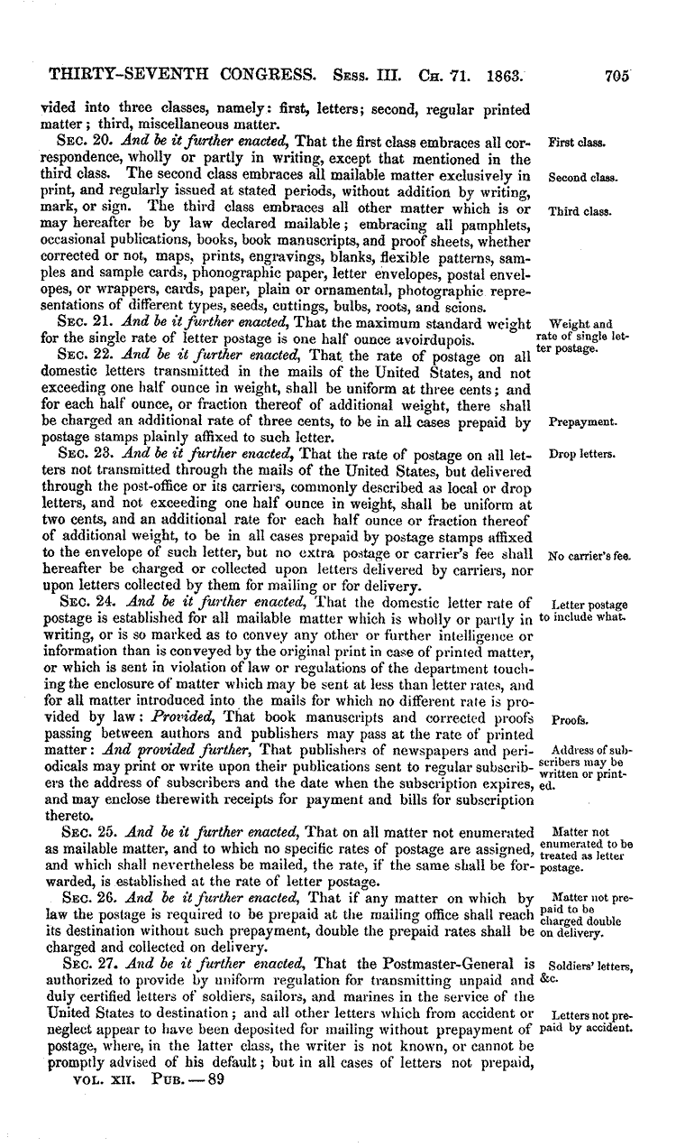
- “Law Department

Welcome to the United States Postal Service Law Department home page. Staffed with over 200 career attorneys in offices across the country, the Law Department provides top-quality, in-house legal representation to the United States Postal Service, an independent establishment of the executive branch. The Law Department effectively functions as a large law firm with an enormously varied practice. Attorneys for the Postal Service practice in many areas, including: labor and employment, commercial, torts, economic regulation, finance, contracts, intellectual property, real estate, legislation, administrative, international, information, government ethics, and consumer protection law.
About the Law Department
Thomas J. Marshall, General Counsel and Executive Vice President HTM | PDF
Commitment to Ethics
The Postal Service demands an unwavering commitment to strong ethical values and principled decision making from all of its employees. All postal employees are required to place loyalty to the Constitution, the laws and ethical principles above private gain. Section 662.1 of the Postal Service's Employee Labor and Relations Manual provides:
To ensure that every citizen can have complete confidence in the integrity of the federal government, each federal employee, including each postal employee, must respect and adhere to the principles of ethical conduct set forth in 5 CFR 2635 [the Standards of Ethical Conduct for Employees of the Executive Branch; see also Overview of Standards], 5 CFR 7001 [the Supplemental Standards of Ethical Conduct for Employees of the United States Postal Service], and 39 CFR 447 [the Rules of Conduct for Postal Employees] and summary of Ethics Topics (pdf).
For questions related to Postal Service employees and the Standards of Ethical Conduct for Employees of the Executive Branch, please call the Postal Service’s Ethics Helpline at 202-268-6346 or send an e-mail to ethics.help@usps.gov.
Customer Service or Mail Delivery Issues: Call 1-800-ASK-USPS® (800-275-8777)
Misconduct by a Postal Service Employee: Call 1-888-877-7644
Mail Fraud: Call 1-800-372-8347
- Senior Financial Managers’ Code of Ethics
The Sarbanes Oxley Act of 2002 (SOX) was enacted to improve corporate governance and to enhance the accuracy of financial reporting. The Senior Financial Managers’ Code of Ethics affirms our commitment to full and accurate financial reporting.” (https://about.usps.com/who-we-are/legal/welcome.htm)

39 CFR § 447.21 Prohibited conduct.

“(c) No employee while acting in his official capacity shall directly or indirectly authorize, permit, or participate in any action, event or course of conduct which subjects any person to discrimination, or results in any person being discriminated against, on the basis of race, color, religion, sex, national origin, or age.
(d) No employee shall engage in criminal, dishonest, notoriously disgraceful or immoral conduct, or other conduct prejudicial to the Postal Service. Conviction of a violation of any criminal statute may be grounds for disciplinary action by the Postal Service in addition to any other penalty imposed by or pursuant to statute.”

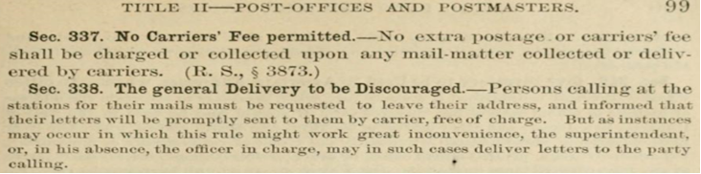
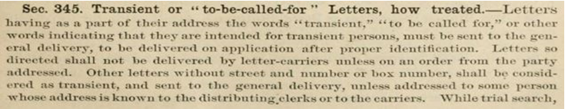
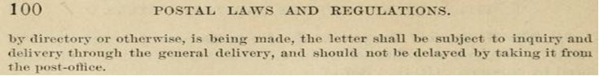
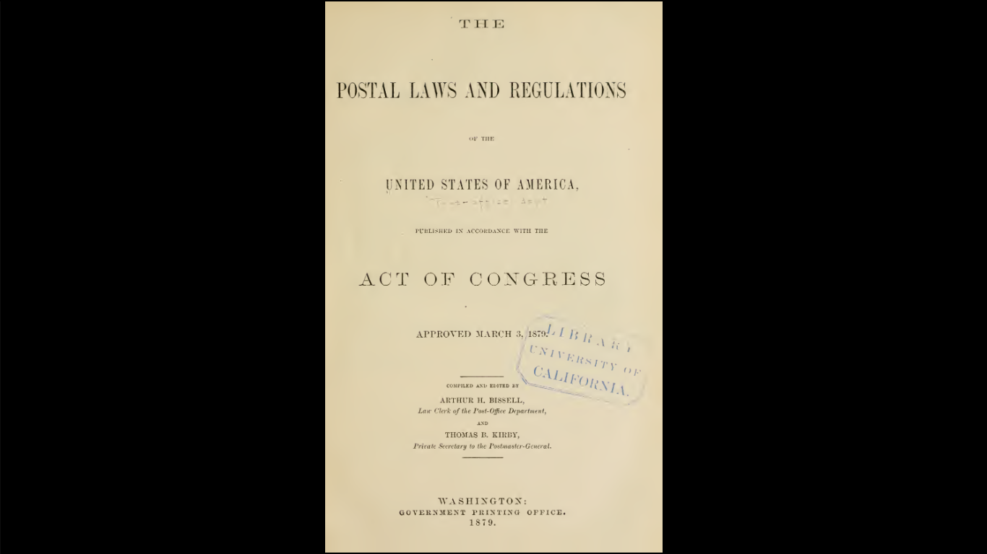
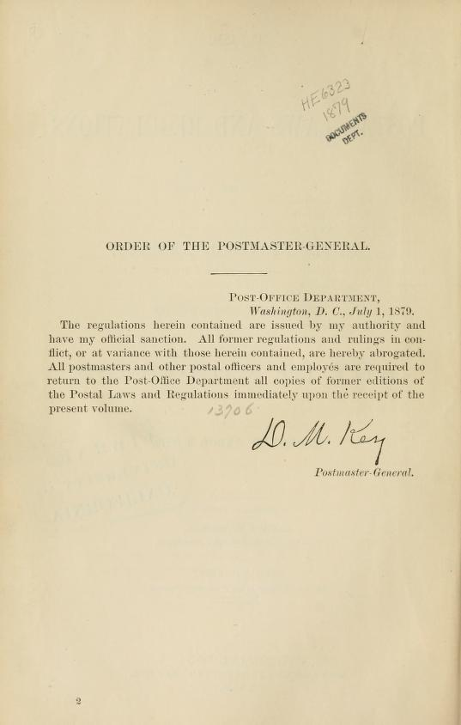
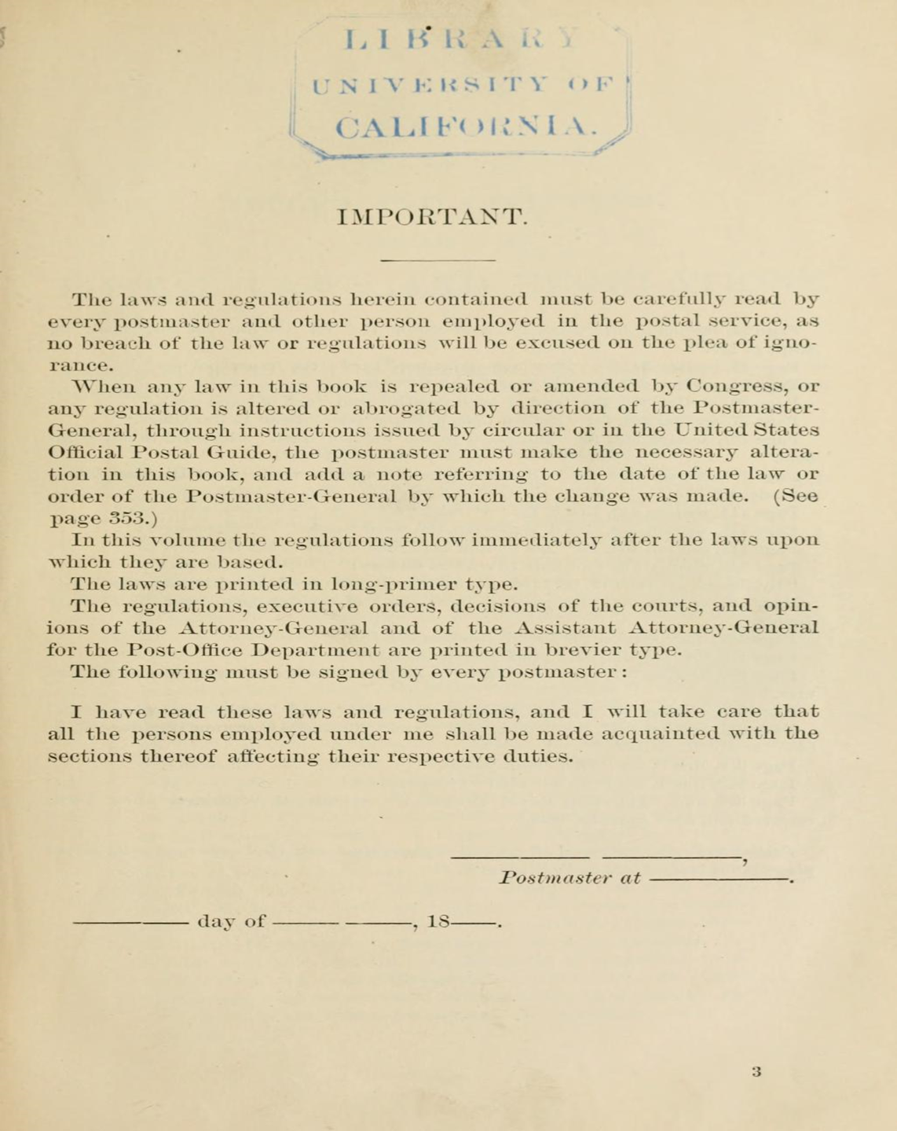
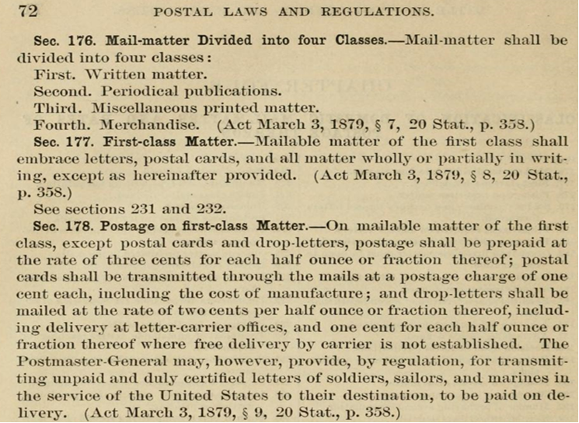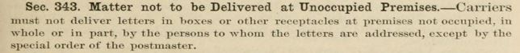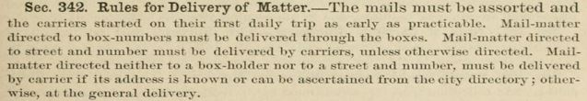
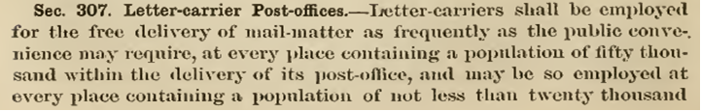

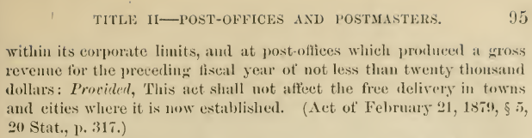

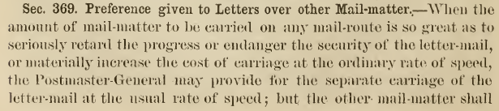

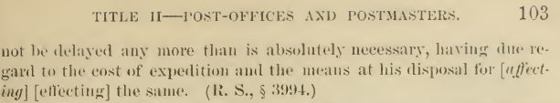

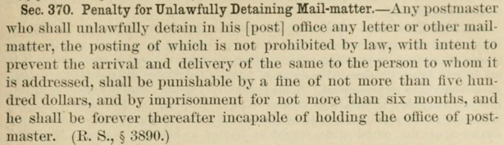
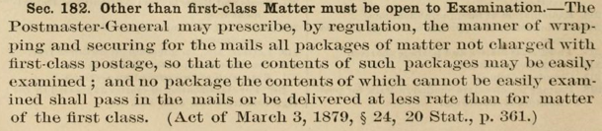
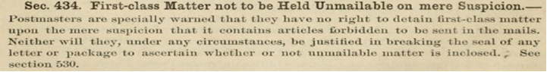
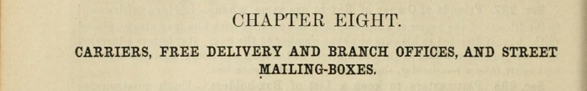
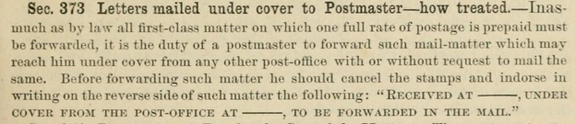
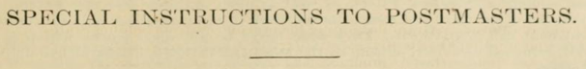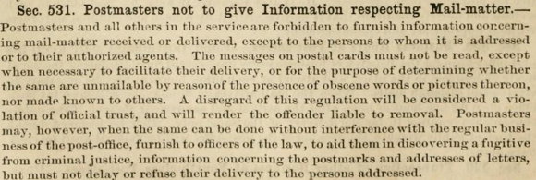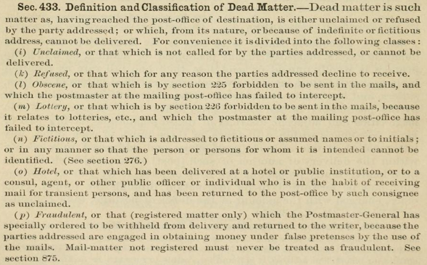
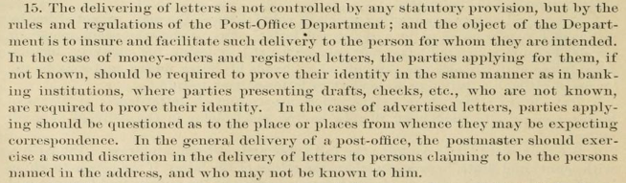
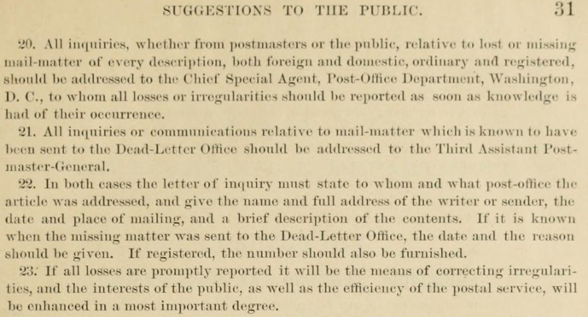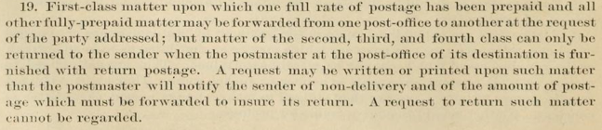
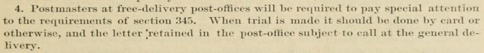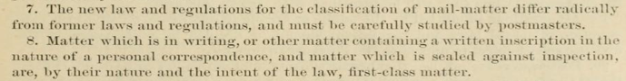
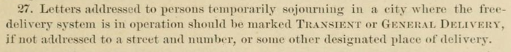
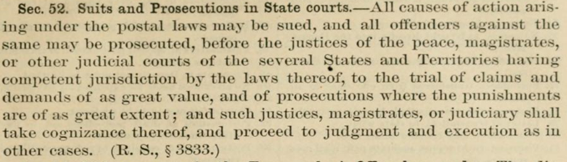
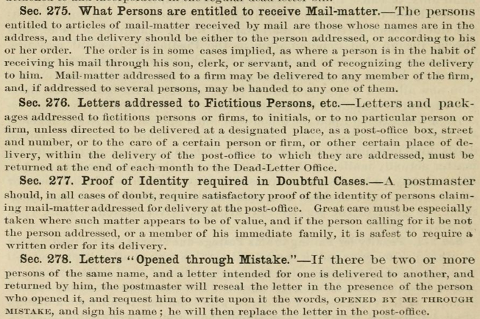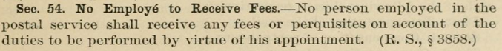

Above: Proof of identification “require the exhibit the same superscription and seal that are upon the letter”

- Postal Reorganization Act

Letter carriers, 1946
Letter carriers, 1946
In May 1969, four months after he became a member of President Richard Nixon's Cabinet, Postmaster General Winton M. Blount proposed a basic reorganization of the Post Office Department. The President asked Congress to pass the Postal Service Act of 1969, calling for removal of the Postmaster General from the Cabinet and creation of a self-supporting postal corporation wholly owned by the federal government.

- United States Postal Service

“The Post Office Department was transformed into the United States Postal Service, an independent establishment of the executive branch of the Government of the United States. The mission of the Postal Service remained the same, as stated in Title 39 of the U.S. Code: "The Postal Service shall have as its basic function the obligation to provide postal services to bind the Nation together through the personal, educational, literary, and business correspondence of the people. It shall provide prompt, reliable, and efficient services to patrons in all areas and shall render postal services to all communities."

Title 39, the Postal Reorganization Act, also vested direction of the powers of the Postal Service in an 11-member Board of Governors. Nine members (the Governors) are appointed by the President, by and with the advice and consent of the Senate. They serve staggered nine-year terms, and no more than five Governors may belong to the same political party. Governors are chosen to represent the public interest generally, may not represent specific interests using the Postal Service, and may be removed only for cause.”
- ZIP Code

“…ZIP Code began on July 1, 1963, as scheduled. Use of the new code was not mandatory at first for anyone, but, in 1967, the Post Office required mailers of second- and third-class bulk mail [not first class] to presort by ZIP Code. Although the public and mailers alike adapted well to its use, it was not enough.” 